Gibson-Neill Home and School Committee

Help fundraise and feed your family at the same time!
For only $30 you can have a fresh box of vegetables grown locally in New Brunswick. Each farm fresh vegetable box includes:
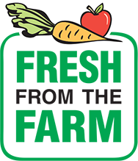
- Russet Potatoes 5lbs
- Carrots 5lbs
- Gala Apples 3lbs
- Organic Red Onions 2lbs
- Organic Red Beets 2lbs
- Turnip
- Cabbage

$9 from every box sold goes directly to the Home and School to support school activities!

Please feel free to ask your friends and family if they would like to take advantage of this great deal but we do not recommend door-to-door sales. Order forms must be returned with cash only by Tuesday, April 3rd (order will be placed on April 4th and we are unable to accept any further orders once the order is placed). Farm boxes will be available for pick up at Gibson-Neill Elementary on Thursday, April 12th.

Student’s Teacher:
Student’s Name:

Number of Boxes: __________Total Amount:
Please retain bottom portion for your records

Name | Number of boxes | Paid

